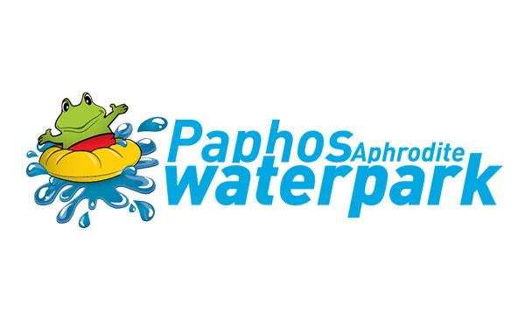

A&A SUPER APHRODITE PARK LTD - Poseidonos Avenue
P.O Box 61357, 8133 - Paphos , Cyprus
Tel: 26 913 638 Website: www.aphroditewaterpark.com

PAID
SEASON PASS FORM ADULT
CARD No:
1 | FULL NAME
2 | AGE
3 | COUNTRY/CITY
4 | SIGNATURE
5 | TEL
6 | EMAIL

A&A SUPER APHRODITE PARK LTD - Poseidonos Avenue
P.O Box 61357, 8133 - Paphos , Cyprus
Tel: 26 913 638 Website: www.aphroditewaterpark.com

TERMS AND CONDITIONS:
The card may only used by the authorised holder described above and on the front of the card.
It is illegal to copy, loan, rent or sell the card anyway.
The company reserves the right to withdraw the card in any case of misuse.
In case the authorised holder loses the card, he/she must notify the company immediately.

By signing this document you provide A&A Super Aphrodite Park Ltd with the permission to retain your data for the duration of this season (until 31 October). All personal data will be stored securely. All personal data will be retained for 1 year (for one season) and will then be securely erased or shredded. No unnecessary data will be collected and no data will be passed on to a third person, other than required by the laws of Cyprus.

Signature ............................... Date .................................

